Window handling
- get all the window elements in a set
- Store in a list
- use “switchTo().window(lst.get(location))” to get each webelement
- use close() for window closing
- To move base window use dr.switchTo.defaultContent() or use dr.getWindowHandle()
- dr.switchTo.newWindow(WindowType.TAB) for new page
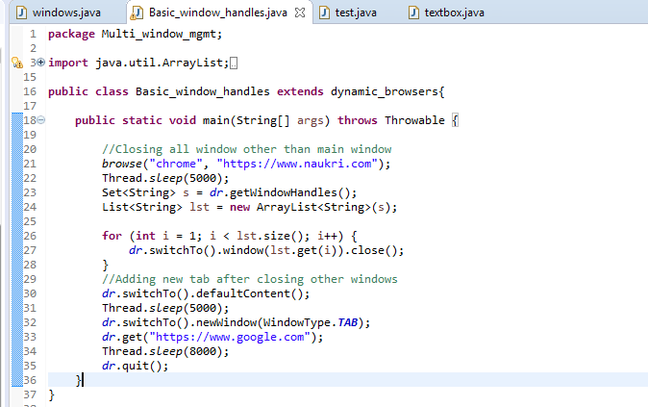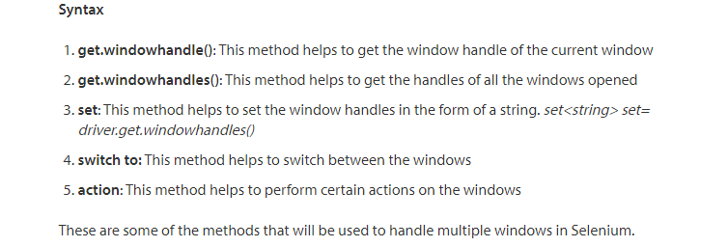

Collections
Linked List
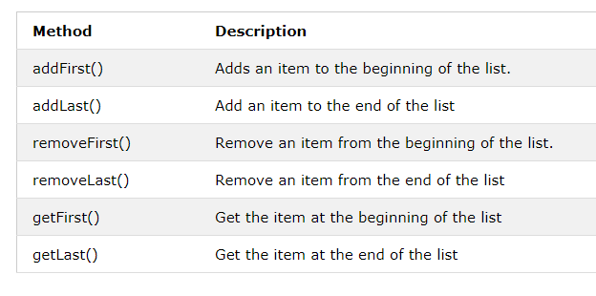
Example
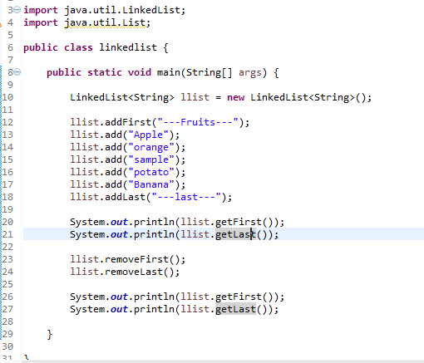

SET

* Set used specifically to store additional windows objects and we can store other values too.
* Set will not allow duplicate values
* Set will keep the records in random order. So if we want that to be in sorter order we must go for treeset.

Example1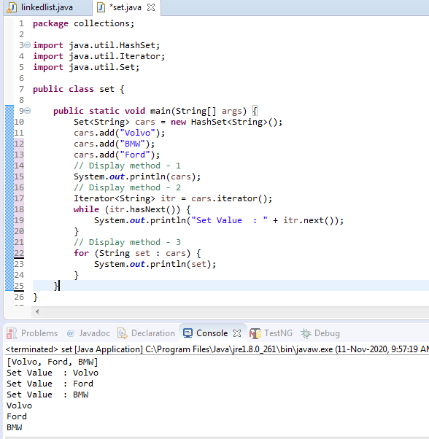
Example2: 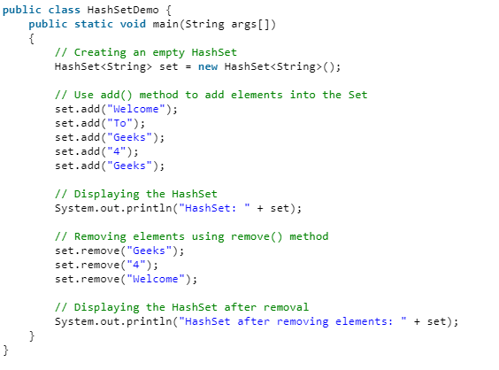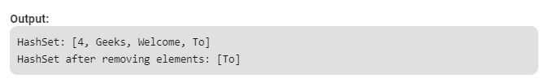

Map Stores data in key and value pair model 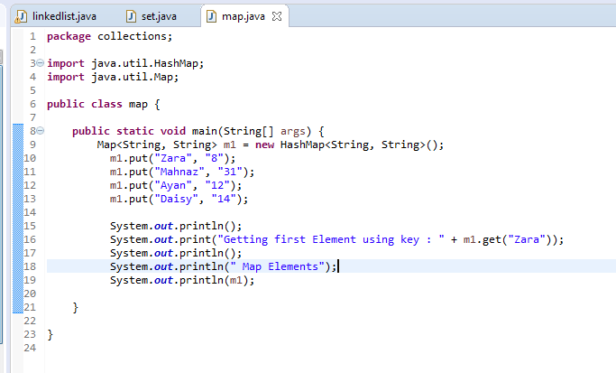 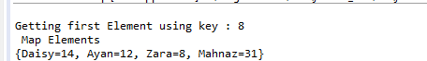

TreeMap 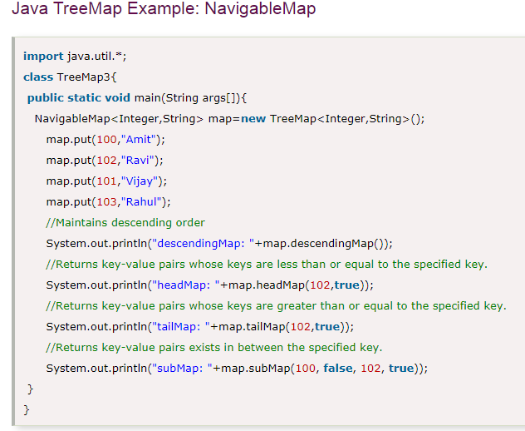 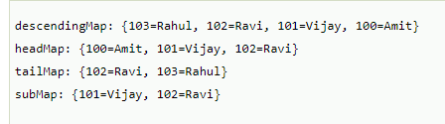
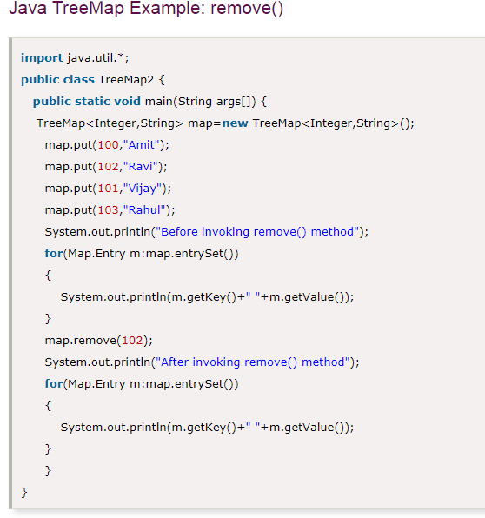

File Handling

Property Files creation and storing value

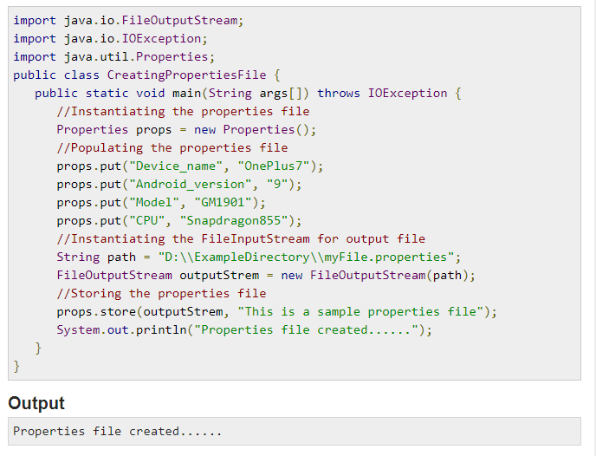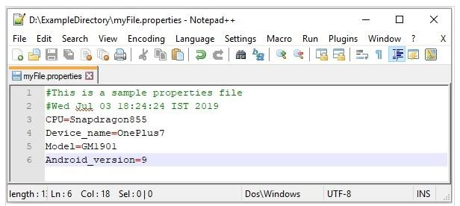

Property file reading 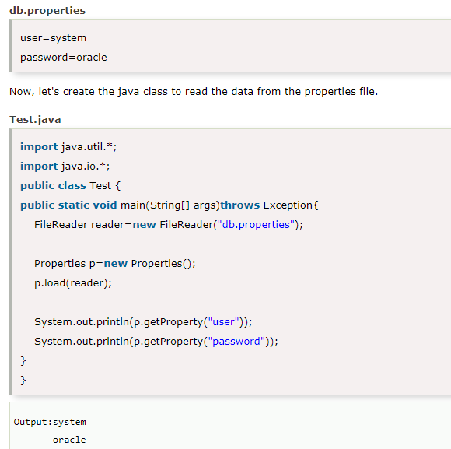

Pattern Matcher
